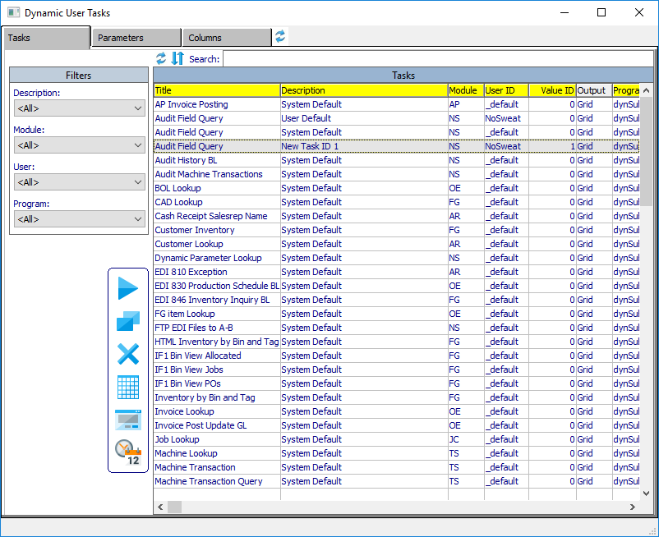

**DAOA**

By Ron Stark

Advantzware, Inc.

Dynamic Advantzware Open Analytics: Tasks User Guide

Table of Contents

Main Menu 5

Icons 5

Dynamic Task Results 6

• Refresh 6

• Delete 6

• View 6

• Archive 6

Dynamic User Tasks 7

• Tasks [Tab] 7

o Filters 7

o Restore Defaults 7

o Toggle Sort/Move Columns 7

o Search 7

o View 8

o Copy Task 13

o Delete Task 13

o Run Now 13

o Set External Form 14

o Schedule Task 14

• Parameters [Tab] 14

o Email (recipients) 15

o Set Alignment 15

o Default Output Format 15

o Show/Hide Parameter Sets 16

o Save 17

o Show [toggle boxes] 17

• Columns [Tab] 17

o Move Up 17

o Move Down 17

o Group Calculations 18

o Save 18

• Restore Defaults 20

Dynamic Task Scheduler 21

• Refresh Defaults 21

• Toggle Sort/Move Columns 21

• Run Now 21

• View 21

• Show Tasks 21

• Show History 21

• Search 21

• Close (viewer) 21

• Update / Save 21

• Add 22

• Copy 22

• Delete 22

• Reset 22

• Cancel 22

• Run Now 22

• First 22

• Previous 22

• Next 22

• Last 22

• Task Scheduler Fields 22

o Parameter Value/Task ID 22

o Task Name 22

o User ID 22

o Security Level 22

o Scheduled 22

o Program 22

o Title 22

o Subject ID 22

o Module 22

o Frequency 22

o Run Now 23

o Start Date 23

o End Date 23

o Next Date 23

o Next Time 23

o Last Date 23

o Last Time 23

o Email (recipients) 24

Task Monitor (ND1) 25

• Show Logging 25

• Hide Logging 25

• Clear Is Running 25

• Clear (Pending Emails) 26

Configurations (NS3) 27

• Configurations Fields 27

o SMTP Server 27

o SMTP Port 27

o SMTP User 27

o SMTP Password 27

o Email Subject 27

o Email Body 27

o Cue Card Notification 27

Jasper Starter 28

• Installation 28

• Verification of install 32

Main Menu Dynamic User Tasks have three components that are accessed via icons located on the top row of the Main Menu, along with Menu Options Task Monitor (ND1) and Configurations (NS3).

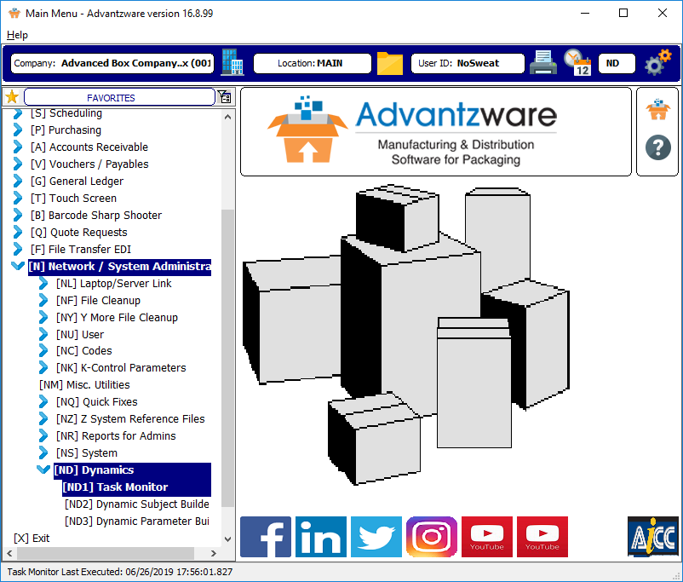

**Note**: lower left corner shows Task Monitor Last Executed: [Date] [Time] which auto refreshes every 10 seconds when Task Monitor is running.

Icons

1.  **Dynamic Task Results**
2.  **Dynamic User Tasks**
3.  **Dynamic Task Scheduler**
4. **Task Monitor (ND1)**
5. **Configurations (NS3)**

Dynamic Task Results  presents a display of Task Result files which are the generated result from a user’s Run Now  submitted request and/or Tasks executed from within the Task Monitor of Tasks scheduled from the Dynamic Task Scheduler .

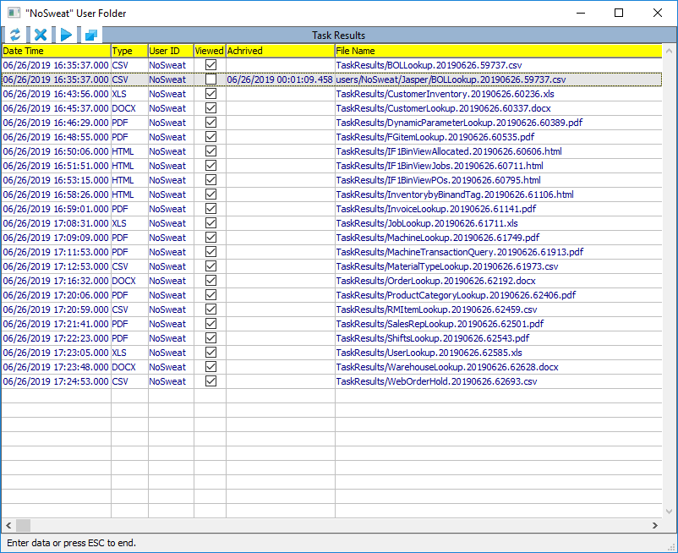

* Refresh  scans the folder “TaskResults” and local user folders for Task Result files to sync newly added and/or removed Task Results.
* Delete  removes the selected Task Result entry and deletes the physical file from disk.
* View  executes the associated application (cvs: exel, xls: excel, docx: word, pdf: pdf, html: web browser) of the Task Result selected and the Viewed column is set as checked.
* Archive  will create a copy of the selected Task Result into a user’s Jasper folder and log the date and time of the archive.
  + TaskResults/BOLLookup.201906.59737.csv will archive into
  + Users/NoSweat/Jasper/BOLLookup.201906.59737.csv

Dynamic User Tasks  contains Tasks (Dynamic Parameter Value records) built on Dynamic Subjects (ND2) and Dynamic Parameters (ND3) can be identified by the User ID of “_default” along with a Description of “System Default”. Tasks are shown where the Security Level of the Task is less than or equal to a User’s Security Level (NU3 Users). A Task is associated with Parameters [tab] and selectable Columns [tab]. Tasks generated here inherit the Security Level of the User that generates the Task and identified with a Description of “User Default”. Whenever a “_default” Task is executed, a Dynamic Parameter Value record is created with the User’s ID and a Value ID of 0 (zero). This zero record stores the most recent Dynamic Parameter values used, so that whenever a Task is executed, it relies on the zero Parameter ID record to initialize parameter values, screen size and screen position. User ID “_default” Tasks cannot be altered and/or deleted. These are maintained by Advantzware.

* 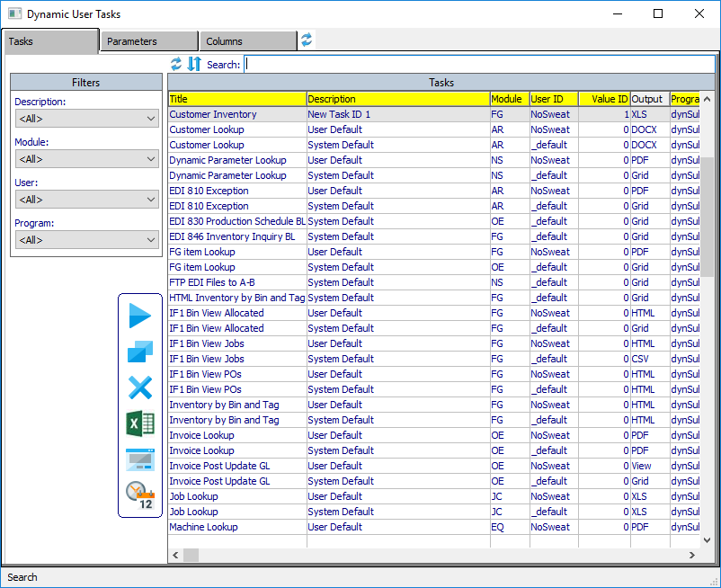
* Tasks [Tab] is the main point of navigation and access to Dynamic User Tasks.
  + Filters can be used to filter the available records based on a Task’s Description, Module, User and/or Program.
  + Restore Defaults  icon just above the Filters and slightly to the right, will restore the default column order and widths.
  + Toggle Sort/Move Columns  /  , by default yellow columns will sort the data when the yellow column header is clicked, ascending and descending. Clicking to toggle this icon, changes from sort mode to allow a user to move and change the column order.
  + Search will auto locate and filter records that match the entered criteria found in the yellow labeled columns.
  + 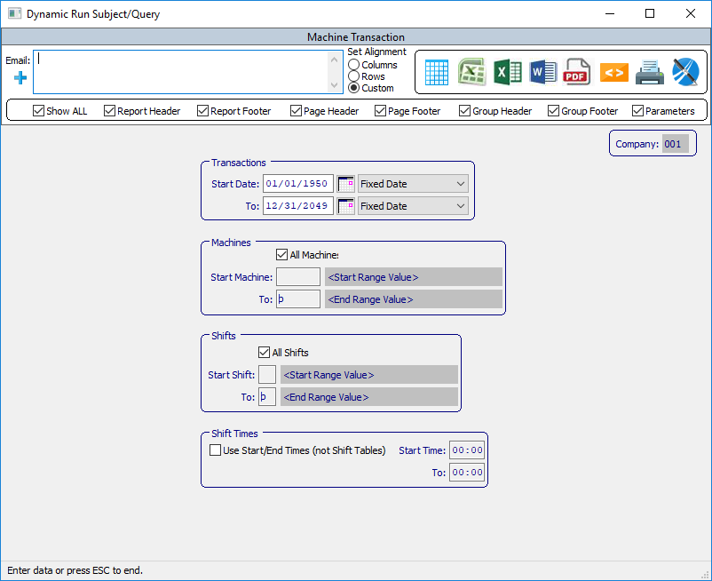
  + View  will run the Dynamic Parameters screen associated with the Task selected.
    - 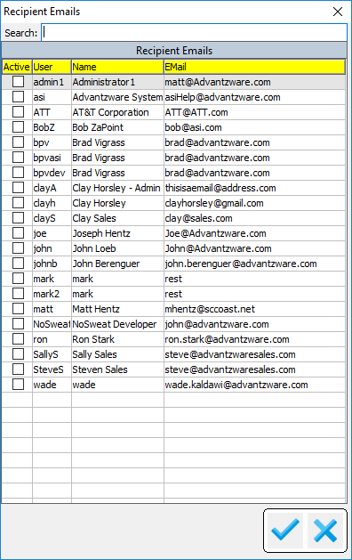
    - Email (recipients)  is a freeform field and relies on the user to enter email addresses properly formatted [*name@domain.com*](mailto:name@domain.com)*.* Clicking the “+” (plus sign) icon, the above popup is presented. It is populated with users (maintained in NU3 Users) which have an email field that is populated.
      * **Search** will auto locate and filter records that match the entered criteria found in the yellow labeled columns.
      * **Save** will auto display any Recipient Emails which have been selected via Active column that has been checked into the Recipients field. Any freeform emails entered will also appear and Active selected. Unchecking the Active column value will remove a freeform email.
      * **Cancel**  will close the Recipient Emails popup without applying any changes to the Recipients field.
    - Set Alignment has no current functionality, may be implemented in a future release.
    - Show [toggle boxes] allows for the various sections of the Jasper Report to be rendered. Show All will toggle all the values ON or OFF. The various sections include Report Header/Footer, Page Header/Footer, Group Header/Footer and if showing the Parameter values on the last page is desired.
    - 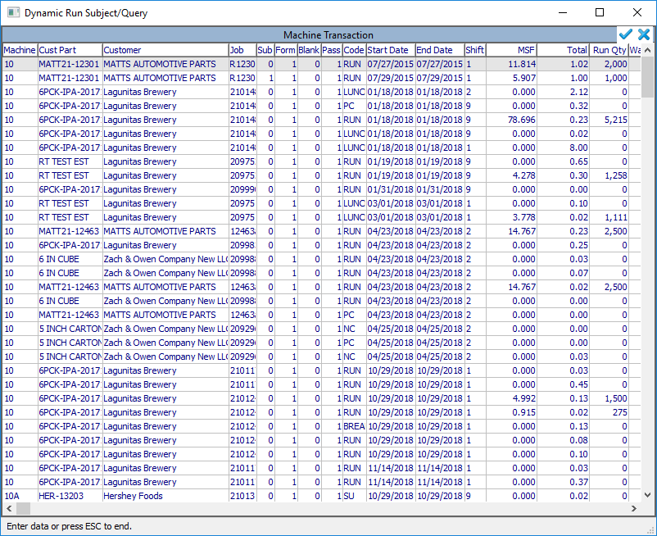
    - Grid renders the dynamic query results to a grid browser. Columns can be re-arranged and column widths can be re-sized and saved.



* + - * Save  will Save any column order and width changes.
      * Cancel  will close the Grid and return to the Parameter screen.
    - Note: when selecting any of the next five options (CSV, XLS, DocX, PDF, HTML) the Task is submitted for processing by the Task Monitor and will prompt with:
    - 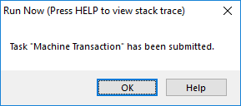
    - CSV creates an Excel CSV Task Result.



* + - XLS creates an Excel Task Result.



* + - DocX creates a Word Task Result.



* + - PDF creates a PDF Task Result.



* + - HTML creates a HTML Task Result.



* + - Printer invokes the Windows Printer Dialog popup.



* + - 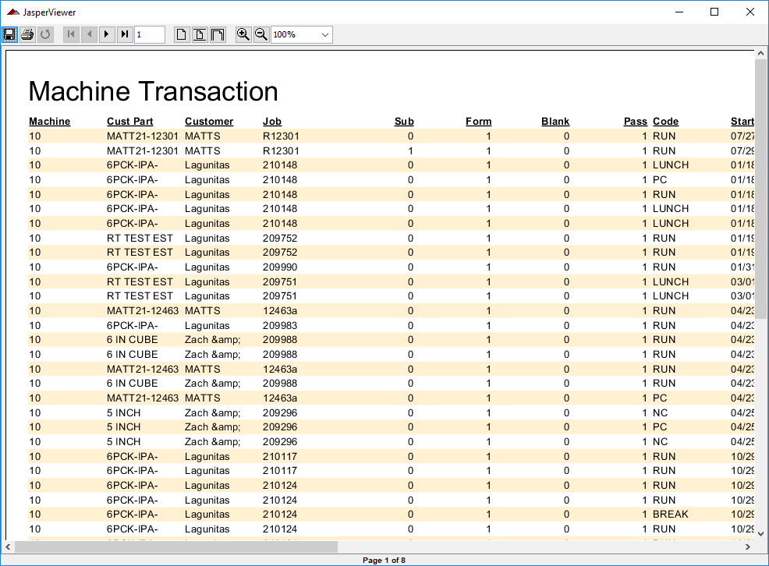
    - Jasper Viewer will run the query results to Jasper Viewer if Jasper Starter is installed locally. When a Viewer session is invoked, a background command window renders and will remain open until the Viewer is closed.



* + - 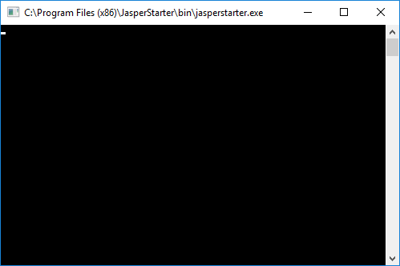
    - Viewer command window.
    - 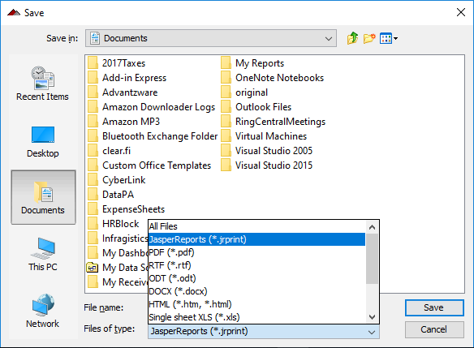
    - Viewer allows the user to Save the results into various formats.
    - 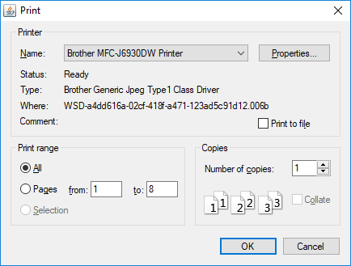
    - Viewer has ability to select and send results to a printer device.
    - Easily navigate to First, Previous, Next, Last Page.
    - 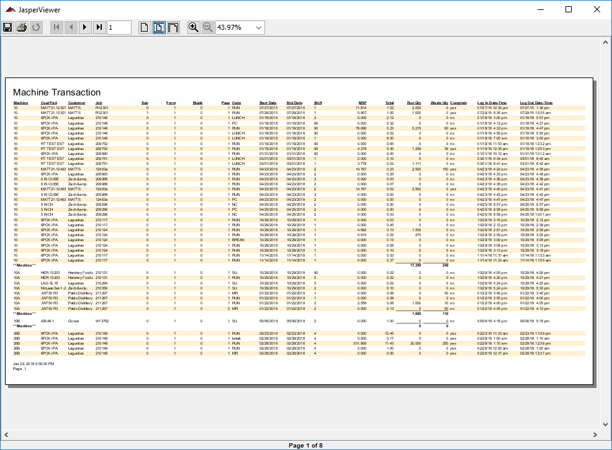
    - Results can be auto sized to fit the Viewer
    - Viewer has functionality to zoom in/out and/or set the display relative percentage size.
  + 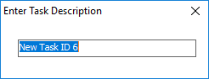
  + Copy Task  in order to Schedule a Task, a Parameter Value ID that is non-zero is required. Executing a Copy will prompt to Enter Task Description. This process will create a unique Parameter Value ID. This Value ID is used when adding a Task into the Dynamic Scheduler , which can be accessed via the Main Menu  Calendar icon.
  + 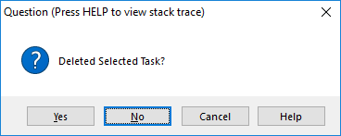
  + Delete Task  only appears for Tasks where the User ID is NOT “_default”. This function removes a Task.
  + Run Now only appears for Tasks where the User ID is NOT “_default”. An icon will display any of the following images  (Grid)  (CSV) (XLS) (DocX)  (PDF)  (HTML). The image displayed is based on what the last output option used to execute the selected Task and will bypass rendering the Parameters screen. The executed Task will use whatever Parameter values existed when last executed.
  + 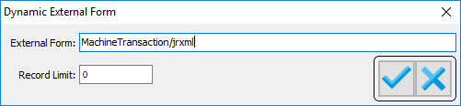
  + Set External Form  only appears for Tasks where the User ID is NOT “_default”. By default, the New Dynamic framework renders the output utilizing Jasper Reports. The Dynamic framework auto generates the Jasper Report, however, a custom, static Jasper Report can be utilized by designating the location and name of the .jrxml file. Some Dynamic Queries may return a large data set. To limit the amount of data returned, a Record Limit value can be designated. A zero value will return all data of the Dynamic Query.
  + Schedule Task  only appears for Tasks where the Parameter Value ID is NOT zero. This allows easy access to the Dynamic Scheduler , which can also be accessed via the Main Menu  Calendar Icon. (See Dynamic Scheduler documentation within this document).
* 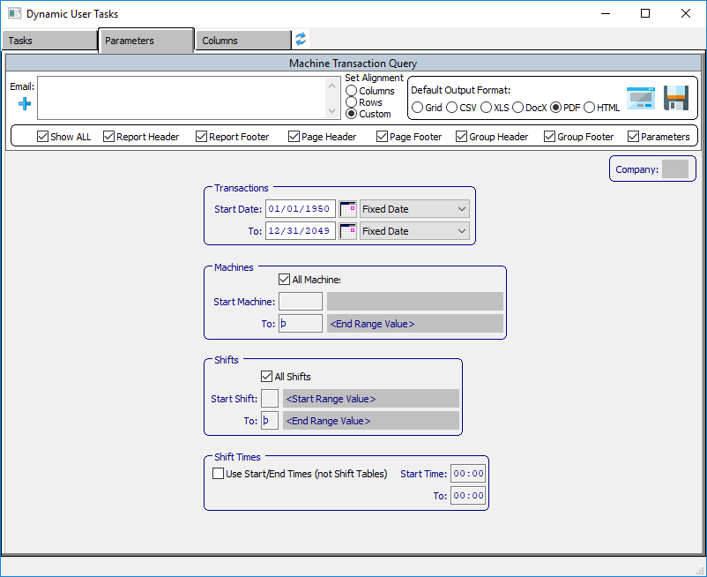
* Parameters [Tab] dynamically renders the Task’s parameters. Users set the Parameter values, along with one or more email recipients, the Default Output and to designate which various Jasper Report sections to Show/Not Show.
  + 
  + Email (recipients)  is a freeform field and relies on the user to enter email addresses properly formatted [*name@domain.com*](mailto:name@domain.com)*.* Clicking the “+” (plus sign) icon, the above popup is presented. It is populated with users (maintained in NU3 Users) which have an email field that is populated.
    - Search will auto locate and filter records that match the entered criteria found in the yellow labeled columns.
    - Save will auto display any Recipient Emails which have been selected via Active column that has been checked into the Recipients field. Any freeform emails entered will also appear and Active selected. Unchecking the Active column value will remove a freeform email.
    - Cancel  will close the Recipient Emails popup without applying any changes to the Recipients field.
  + Set Alignment has no current functionality, may be implemented in a future release.
  + Default Output Format allows the selected Task to set a default output to Grid, CSV, XLS, DocX, PDF or HTML.
  + 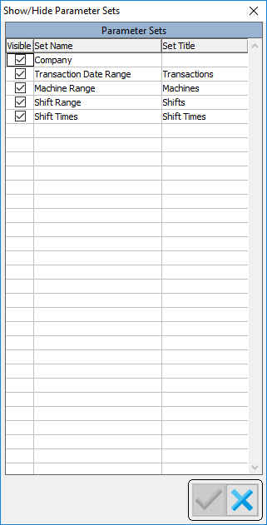
  + Show/Hide Parameter Sets  will only appear when a Task’s User ID is NOT “_default”. Renders a popup that allows for the selection of the various Dynamic Parameter Sets (ND3). Check the Visible column to designate which Sets are visible/hidden. When setting the visible value, tab out of the toggle box or hit ENTER. This will activate the Check icon indicating a value has been changed and needs to be Saved.
    - Save  will Save any changes entered and exit the popup.
    - Cancel  will ignore any changes and exit the popup.
  + 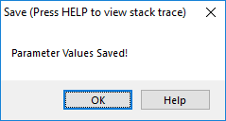
  + Save  will only appear when a Task’s User ID is NOT “_default”. Click to record any value changes to Recipients, Default Output, Show toggle-boxes or any of the Dynamic Parameter Values.
  + Show [toggle boxes] allows for the various sections of the Jasper Report to be rendered. Show All will toggle all the values ON or OFF. The various sections include Report Header/Footer, Page Header/Footer, Group Header/Footer and if showing the Parameter values on the last page is desired.
* 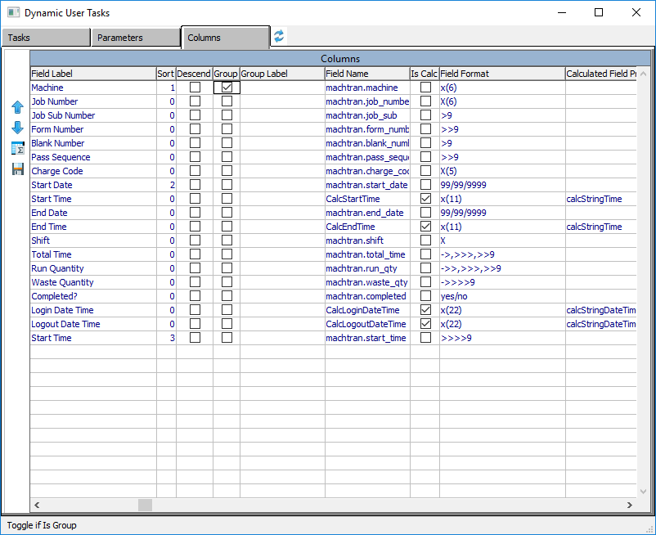
* Columns [Tab] allows for changing the order in which the columns render, setting which columns to sort the report, whether a column is ascending/descending, designate a column as a group for summing, count, average, low value, high value and/or custom calculations, provide a custom group label. To change any of the previously listed columns, simply click into the desire and column and row. After changing the value, tab out of the field or hit ENTER.
  + Move Up  will only appear when a Task’s User ID is NOT “_default”. Will move the selected Column Up in the order in which it will render.
  + Move Down  will only appear when a Task’s User ID is NOT “_default”. Will move the selected Column Down in the order in which it will render.
  + 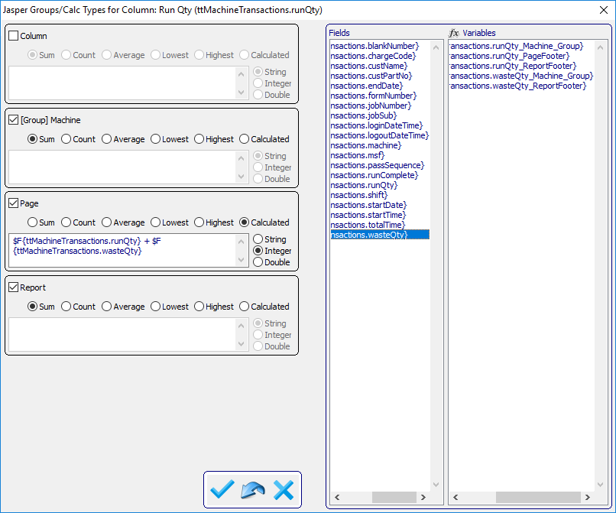
  + Group Calculations  will only appear when a Task’s User ID is NOT “_default”. There are three default Groups (Column, Page and Report). If any Column was designated as a Group, that Column will also appear labeled [Group] <Column Label>. In the above image, Machine was selected as a Group and appear as [Group] Machine for the Column Run Qty. Groupings have the option to Sum, Count, Average, Lowest (value), Highest (value) or Calculated. Calculated values can be of data type Character, Integer (non-decimal numbers) or Double (decimal numbers). When building a Calculated value, Fields and Variables are available. Simply place focus into the editor of the Grouping and double click a desire Field and/or Variable. This editor is freeform and requires the user to ensure properly formatted formulas. The nomenclature used for Fields $F{table.field} and Variables $V{table.field_group} is recognized by the Jasper Framework and is formatted to match the auto generated Jasper Report syntax.
    - Save  will Save any changes entered and exit the popup.
    - Reset  will restore any changes values to their prior setting.
    - Cancel  will ignore any changes entered and exit the popup.
  + Save  will only appear when a change to any of the data is detected. This will Save the changes and auto hide itself.
  + 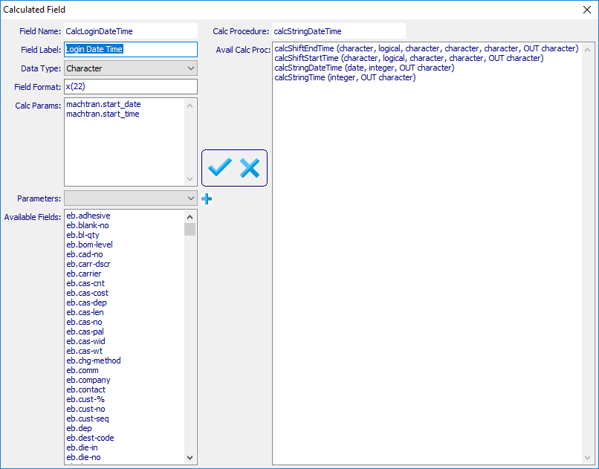
  + **Calculated Field**  facilitates the creation of a calculated field utilizing database fields in conjunction with developer created functions and renders when the column Is Calc is checked.
    - **Fields**
      * Field Name is auto generated based on the Field Label value entered, which always begins with “Calc” and the Field Label with any blanks removed.
      * Field Label is a freeform entry.
      * Date Type options are Character, Date, Decimal, Integer and Logical.
      * Field Format is a freeform entry and needs to be properly entered based on the Data Type.
      * Calc Params entries are made by double clicking any field found in the Available Fields selection list. Double click an entry to remove the field from Calc Params.
      * Parameters is populated with Parameter values from the associated Subject Parameter Sets and will add a selected Parameter using the add  icon.
      * Available Fields is populated based on the fields associated with a Subject’s query tables.
      * Calc Procedure displays the selected Avail Calc Proc.
      * Avail Calc Proc is a list of the procedures found within the SUPER-PROCEDURE AOA/spDynCalcField.p.
    - **Save**  performs a save of the values entered and exits this popup module.
    - **Cancel**  exits this popup module.
* Restore Defaults  icon to the immediate right of the Columns [tab] will restore the screen size and position to the “Default” values.

Dynamic Task Scheduler 

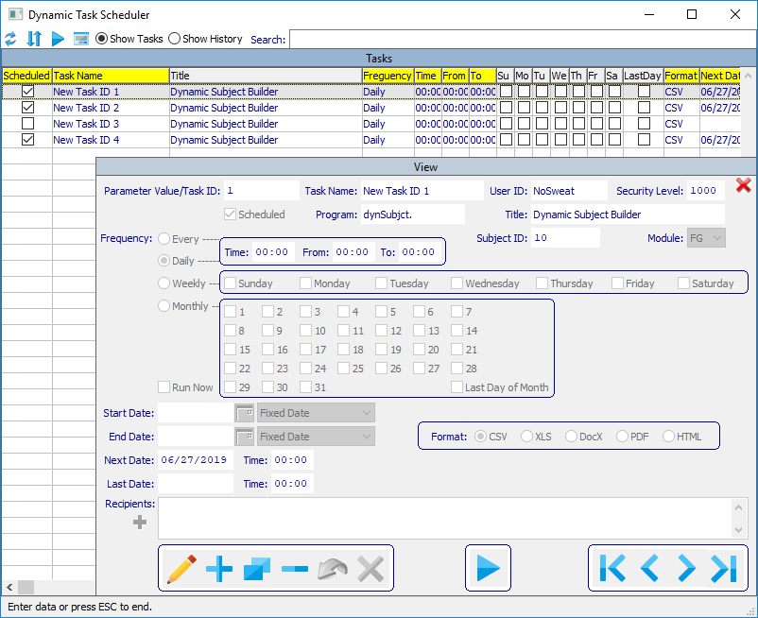

* Refresh Defaults  to original size and screen position, which are saved for each unique user when exiting.
* Toggle Sort/Move Columns  /  , by default yellow columns will sort the data when the yellow column header is clicked, ascending and descending. Clicking to toggle this icon, changes from sort mode to allow a user to move and change the column order.
* Run Now  will submit the selected task to the Task Monitor (ND1) for execution using the Parameter values associated with the Subject/Parameter Value ID.
* View  toggle the View of the selected Task to open, if closed, which allows the user the functionality to Update/Add/Copy/Delete a Task, or to close the Viewer, if open.
* Show Tasks shows current list of Tasks.
* Show History shows the Audit History of the selected Task. Audit History can be accessed via Menu Option NS5.
* Search will auto locate and filter records that match the entered criteria found in the yellow labeled columns.
* Close (viewer)  closes the detail view when open.
* Update / Save  /  when the first icon is a pencil, will place the View into UPDATE mode and changes the icon to a floppy disk, when performs a SAVE operation, after which will change back to the pencil image.
* Add  creates a new blank Task and prompts for a Parameter Value ID generated in Dynamic User Tasks , which accessed via the Main Menu  Printer Icon.
* Copy  create a copy of the currently selected Task. This allows the same Parameter Value ID to be used numerous times with differing Scheduled Dates and Times.
* Delete  will remove the selected Task.
* Reset  when in Update/Copy mode will restore the field values of any changed fields to their original values.
* Cancel  when in Update/Add/Copy mode, will cancel the selected mode and return to View mode.
* Run Now  will submit the selected task to the Task Monitor (ND1) for execution using the Parameter values associated with the Subject/Parameter Value ID.
* First  positions to the First Task record.
* Previous  positions to the Previous record relative to the currently selected Task.
* Next  positions to the Next record relative to the currently selected Task.
* Last  positions to the Last Task record.
* Task Scheduler Fields
  + Parameter Value/Task ID is generated within Dynamic User Tasks , which is accessed via the Main Menu  Printer Icon and validated against an existing Dynamic Parameter Value record.
  + Task Name during an Add operation will auto populate from the Dynamic Parameter Value record and can be over written.
  + User ID is read only and auto populated with the user id of the user performing an Add/Copy operation.
  + Security Level auto populated with the user’s security level (set in NU3 Users) performing an Add/Copy operation.
  + Scheduled allows the Task Monitor (ND1) to execute a Task on a predetermined Frequency/Next Date/Next Time values. When unchecked, no Next Date/Next Time values will exist.
  + Program is read only and auto populated with the Program ID, maintained in the Program Master (NS8), which exists in the Dynamic Parameter Value record.
  + Title is read only and auto populated from the Program Master (NS8) Title value, using the Program field value.
  + Subject ID is read only and auto populated with the values found in the Dynamic Parameter Value record.
  + Module is read only and auto populated with the values found in the Dynamic Parameter Value record.
  + Frequency options Every, Daily, Weekly and Monthly (Note: time entries are to be entered in military time format)
    - Every option
      * Time interval between when a Task is submitted for execution.
      * From starting time of day when a Task can first be submitted.
      * To ending time of day when a Task will cease to be submitted.
    - Daily option relies on the time entered to indicate at what time of the day for a Task to be submitted.
    - Weekly option relies on the time entered to indicate at what time of the day and one or more days of the week, Sunday, Monday, Tuesday, Wednesday, Thursday, Friday, Saturday for a Task to be submitted.
    - Monthly option relies on the time entered to indicate at what time of the day and one or more days of the month from 1 to 31, and/or Last Day of Month for a Task to be submitted.
  + Run Now is auto set by the Task Monitor when a Task has been submitted as a Run Now operation. If a Task fails to complete in the Task Monitor and the Run Now flag remains set, the Task will remain in the Task Monitor queue. Unchecking this value will allow the Task Monitor to auto remove it from the queue.
  + Start Date if populated indicates the when a Task can start to be submitted.
  + End Date if populated indicates when a Task will cease to be submitted.
  + Next Date is read only and will auto populated during a Save operation when a Task Scheduled is checked and is based on the values of Frequency and Time(s).
  + Next Time is read only and will auto populated during a Save operation when a Task Scheduled is checked and is based on the values of Frequency and Time(s).
  + Last Date is read only and is auto populated by the Task Monitor when a Task was last submitted.
  + Last Time is read only and is auto populated by the Task Monitor when a Task was last submitted.
  + 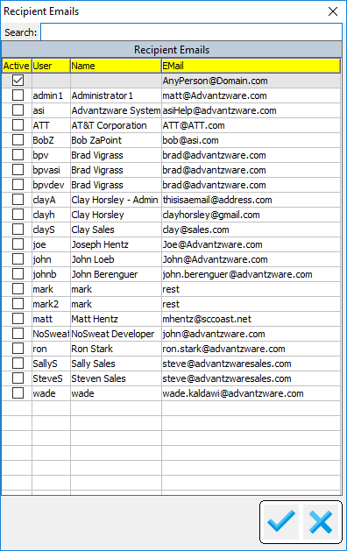
  + Email (recipients)  is a freeform field and relies on the user to enter email addresses properly formatted [*name@domain.com*](mailto:name@domain.com)*.* Clicking the “+” (plus sign) icon, the above popup is presented. It is populated with users (maintained in NU3 Users) which have an email field that is populated.
    - Search will auto locate and filter records that match the entered criteria found in the yellow labeled columns.
    - Save will auto display any Recipient Emails which have been selected via Active column that has been checked into the Recipients field. Any freeform emails entered will also appear and Active selected. Unchecking the Active column value will remove a freeform email.
    - Cancel  will close the Recipient Emails popup without applying any changes to the Recipients field.

Task Monitor (ND1) This module needs to be in a constant state of running to process Run Now submissions and/or entries found in the Task Scheduler which have their scheduled value checked. Ideally this Monitor should be started and running on a system server. It can be run from a client workstation but will span child Progress sessions in order execute and generate a Task Result process.

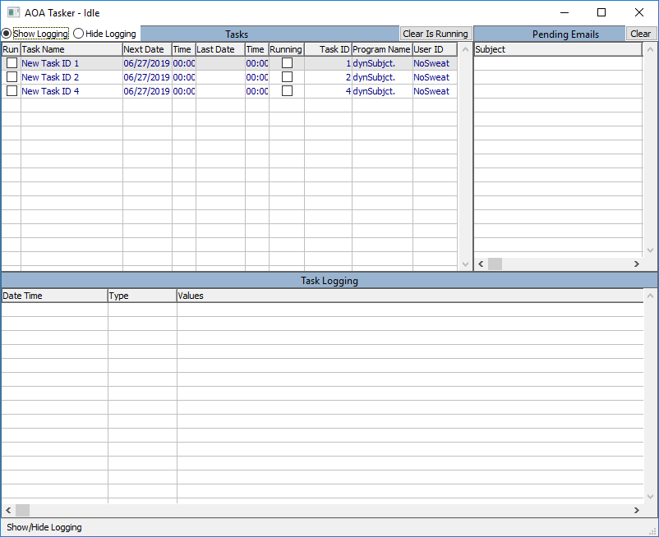

Each spawned process does use a Progress seat license and will remain active until the Task is complete and which time the session will disconnect and close itself. Any user can notice the Task Monitor is up and running by seeing the date and time in the lower left corner of the Main Menu change. The Task Monitor polls the queue entries every 10 seconds.

* Show Logging splits the display into an upper (Task in the Monitor queue) and a lower (Task Logging). The Task Logging displays entries that can be found in NS5 Audit History when a Task is executed and generally shows the generated Task Result. If a Task has email recipients, the execution of the email being sent is also recorded. The Task Logging entries displayed are only those which were created from the time the Task Monitor was opened. To view prior Task Logging, they are found in NS5 Audit History under the Audit Type “Task”.
* Hide Logging will close lower half of the display of Task Logging entries.
* Clear Is Running removes the Run (Is Running) checked value from queue entries. Under normal operations, this field is set when the Monitor has spawned a session to execute the Task. If any event occurs which prevents the spawned process from completing successfully, the queue entry may be in a perpetual state of Is Running. When a spawned progress is created, the monitor has no way of knowing how long the Task will take to complete. Setting the Is Running field prevents the monitor from spawning another session when one may already exist. When a spawned process completes, it removes the Is Running value. With a failed process, this will not occur. So, this function allows an administrator to manually clear the Is Running checked value(s).
* Clear (Pending Emails) will remove Pending Email entries from the monitor’s queue. An administrator may need to execute this function should an event prevent the successful execution of an email being generated and sent to designated recipients. Pending Email entries poll to ensure the attached Task Result exists on disk. If the spawned process to generate the Task Result fails, the polling by the Pending Email entry will never execute and remain within the Monitor’s queue and need to be manually terminated by this function.

Configurations (NS3) Configuration information is needed to process Task Results that have Email Recipients associated with a Task.

* Configurations Fields required:
  + SMTP Server
  + SMTP Port
  + SMTP User
  + SMTP Password
  + Email Subject check one or more of the following to build an email subject:
    - Task Name check to include in email subject.
    - Task Type check to include in email subject.
    - Task Date check to include in email subject.
    - Task Time check to include in email subject.
  + Email Body text that will appear in the email body.
  + Cue Card Notification will display a Cue Card popup to the User ID associated with the Task alerting them that their submitted Task has completed.

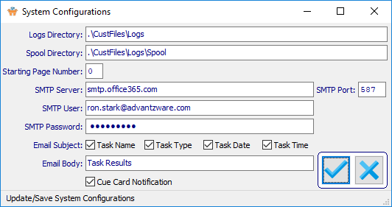

* + - Save click to enable the fields for updating values, click again to Save any changes.
    - Cancel  if in update mode, will cancel and disable fields. If not in update mode, clicking will close this module.

Jasper Starter The Dynamic Task framework relies on the installation of Jasper Starter to be installed on the server in which Task Monitor is running. The Task Monitor can run anywhere on any computer within the network, however, Jasper Starter needs to be installed. It is not recommended more than one Task Monitor be running simultaneously, although it is designed to function successfully. To install Jasper Starter, navigate via Windows Explorer to <drive>:\Install\ReportWriter and execute jasperstarter-3.4.1-Setup.exe. Follow the screen shots below, which requires the installed to simply take all the default settings. The installation person should have Administrator privileges.

* Installation of jasperstarter-3.4.1-Setup.exe

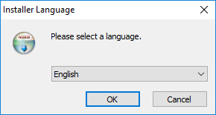

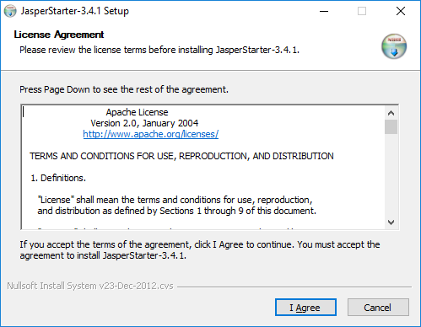

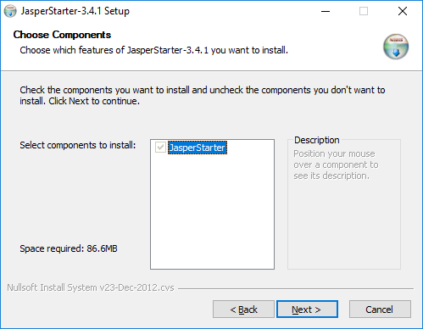

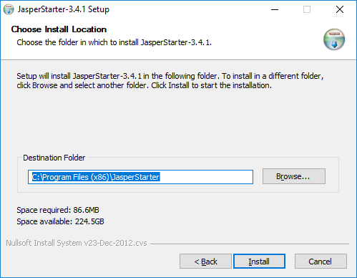

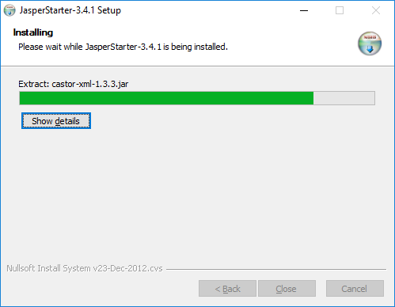

Sometimes expected issue, simply click OK.

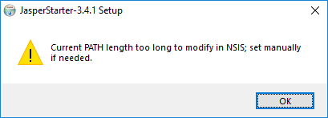

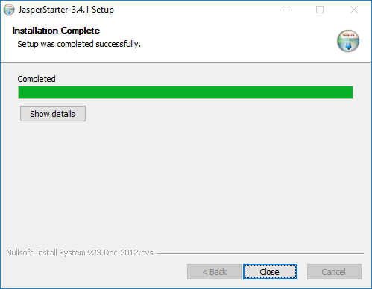

* Verification of install To ensure Jasper Starter installed correctly, run Windows Control Panel

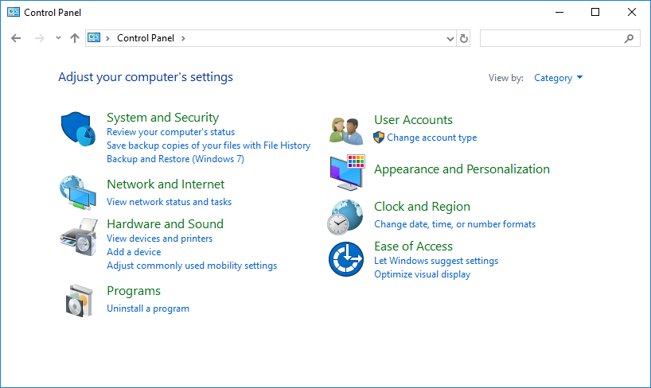

Click on System and Security

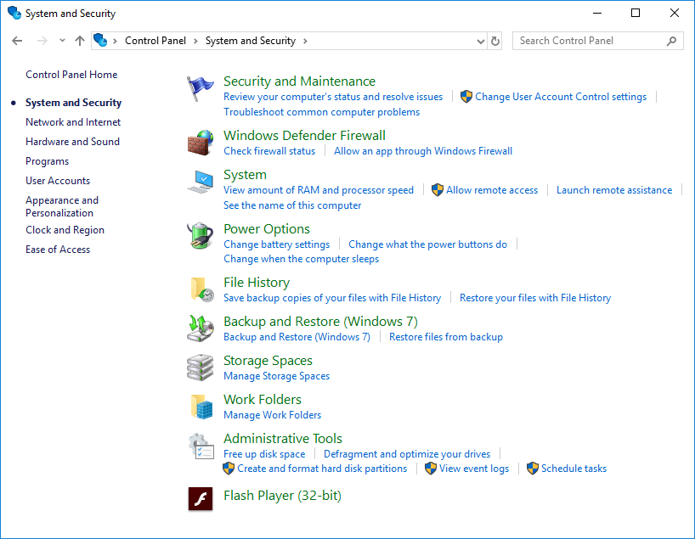

Click on System

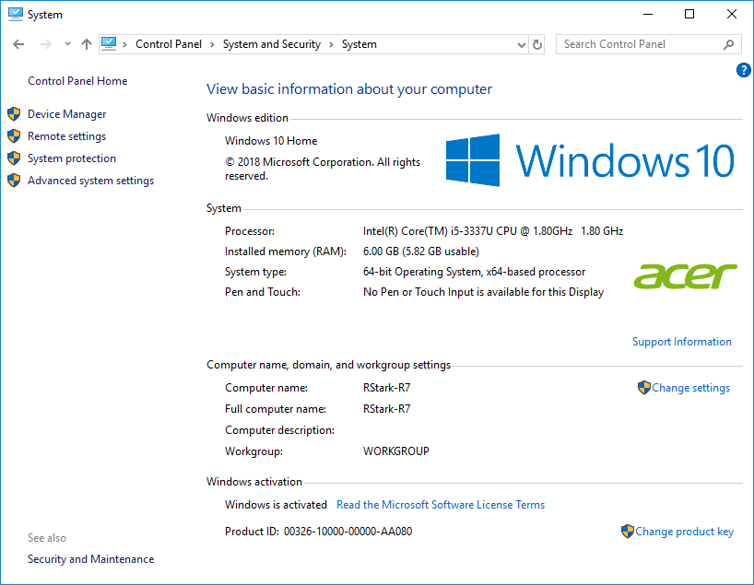

Now select Advanced System Settings

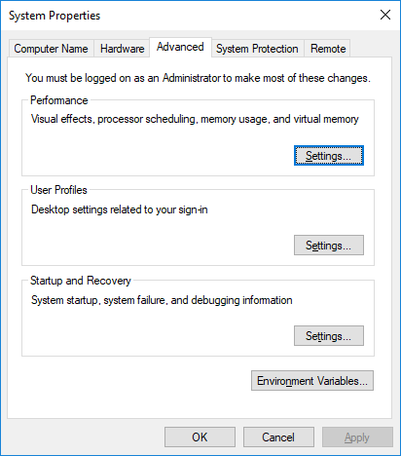

Click Environment Variables

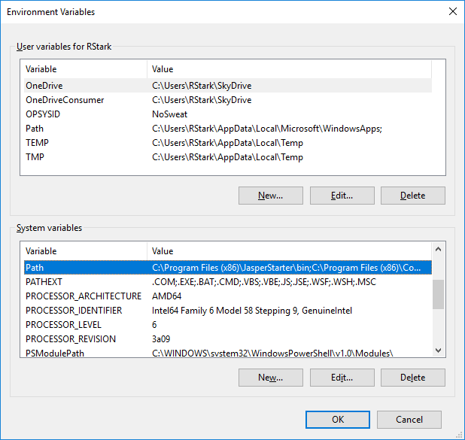

Select the Variable “Path” under System variables and click Edit

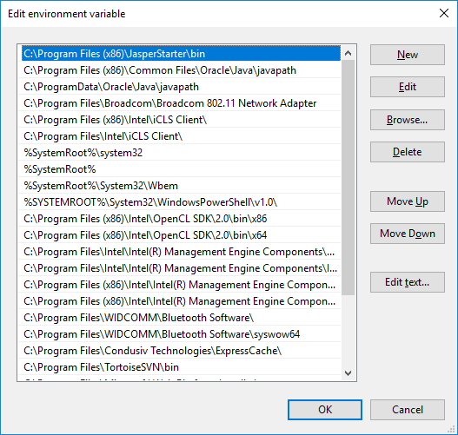

An entry for JasperStarter\bin should exist indicating a successful installation of Jasper Starter.

Another excellent test is to open a Command Prompt (cmd.exe) and type:

jasperstarter -h

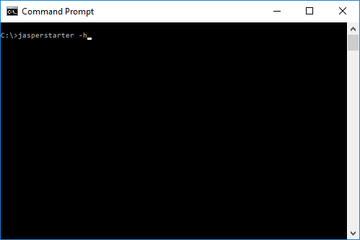

Below is the correct response to the -h option.

